Lab 12:

Threads and locks

Instructions:
Download the starting code, the starting project is a Maven project and already has the solution to lab 11 (double spending problem demo).

- Create a second main program that uses a cached thread pool instead of the fixed thread pool. Compare the performance of both programs for these two cases:
  - When we have 1000 accounts and one million transactions
  - When we have 10 accounts and one million transactions
  - What do you observe:……………………………………….?
The fixed thread pool was four times faster than the cached thread pool when we had 1000 accounts and also when we had 10 accounts, I ran every one three times, in the 1000 accounts part, we had an average of 358 milliseconds(Fixed) vs 1228(Cached), in the 10 accounts part we had an average of 310 milliseconds(Fixed) vs 1255(cached), If we use a fixed thread pool, the number of threads equals the number of CPU cores, and the threads are reused while extra tasks wait in a queue. In the cached pool, tasks are submitted much faster than they finish, so the pool keeps creating new threads and switching between them costs more than the actual work. The number of accounts had almost no impact on the results.

- In the previous solution, replace the use of “synchronized” by “locks”.
- What could go wrong?
After replacing synchronized with locks, each transaction locks the sender account first and then the receiver account. When two transactions run at the same time in opposite directions, the first thread locks A and waits for B, while the second locks B and waits for A. Neither thread can continue so they wait forever, this is a deadlock. When we ran the program with 10 accounts and 1,000,000 transactions, it printed the initial money volume and then froze; it never printed the final money and had to be stopped manually after 37 seconds. I attached a screenshot of the output:
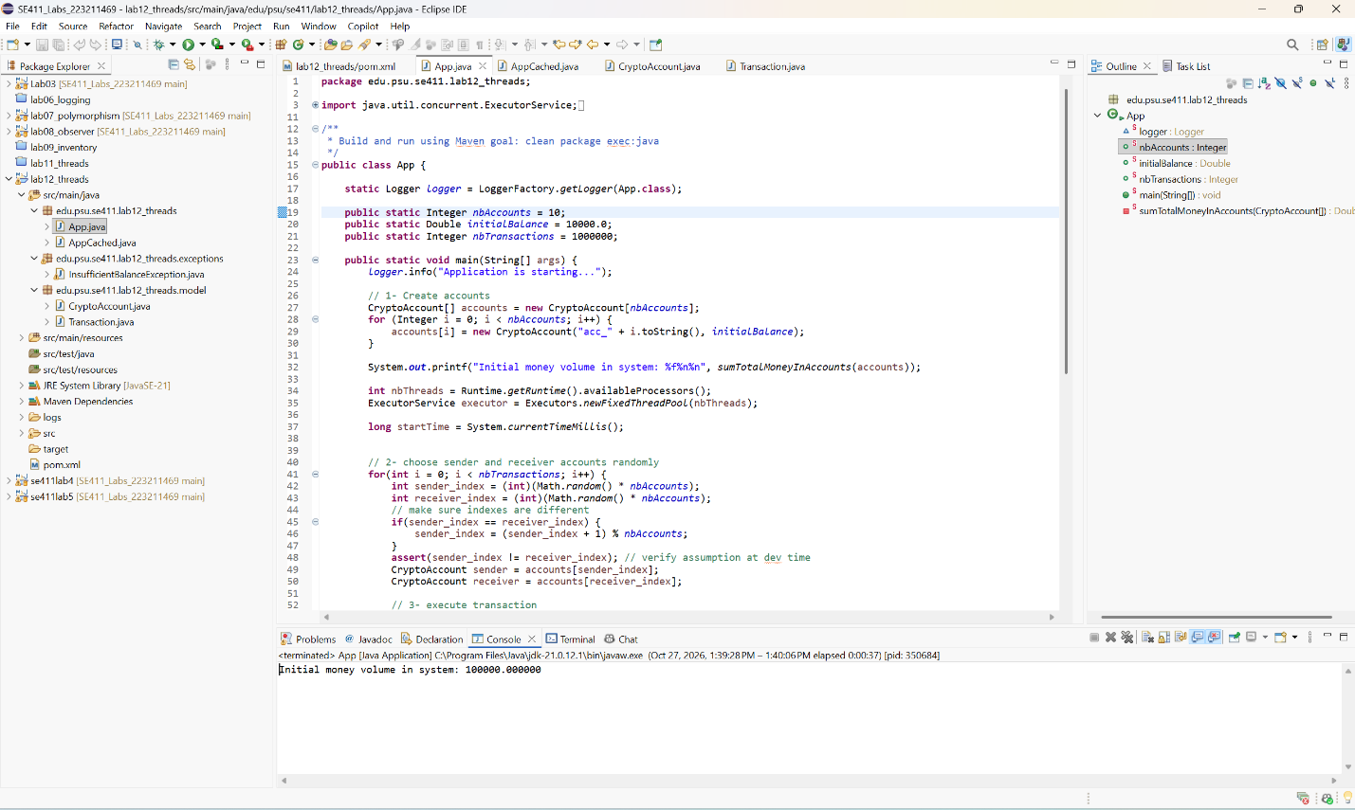

- Solution: implement resource ordering to solve the problem. Create a total order on accounts (using the id for example) then use it to always lock resources in an ascending order.

END

